# 10. Appendix

## Appendix 0: Links

#### Itch - https://morganhodge.itch.io/timeline-takedown

#### Trello - <https://trello.com/b/Y88bQSkB/timeline-takedown>

## Appendix 1: Game Design Documanat

**Game Design Document**

Morgan Hodge

**Timeline Takedown**

Splash Art

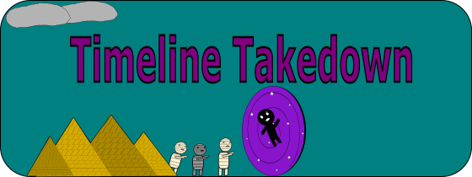

GitHub Repo Link: https://github.com/Mdot5596/Timeline-Takedown.git

Trello: https://trello.com/invite/b/6713ecc23691aeb9441f3609/ATTIc3ced0c9049f3f63121cd6e4215eb400CDAFEF68/timeline-takedown

**Table of Contents**

**Packaging**

Title

Company

Splash Art

Tagline/Hook

**Table of Contents**

**Introduction**

Summary/Pitch

Inspirations

Player Experience

Platform

Software

Genre

Target Audience

[**Concept**](https://docs.google.com/document/d/1KO8kQkX8v7YGZhWu6YUnfmFCRBy0cqZeCmSxHeTVy3k/edit?pli=1#heading=h.6eb2491je91s)

[Core Loop](https://docs.google.com/document/d/1KO8kQkX8v7YGZhWu6YUnfmFCRBy0cqZeCmSxHeTVy3k/edit?pli=1#heading=h.z9birlv3mj2s)

[Themes](https://docs.google.com/document/d/1KO8kQkX8v7YGZhWu6YUnfmFCRBy0cqZeCmSxHeTVy3k/edit?pli=1#heading=h.ikyqv21ny6r0)

[Primary Mechanics](https://docs.google.com/document/d/1KO8kQkX8v7YGZhWu6YUnfmFCRBy0cqZeCmSxHeTVy3k/edit?pli=1#heading=h.alnp73attmr9)

[Secondary Mechanics](https://docs.google.com/document/d/1KO8kQkX8v7YGZhWu6YUnfmFCRBy0cqZeCmSxHeTVy3k/edit?pli=1#heading=h.80s4rl63plm4)

[Tertiary Mechanics](https://docs.google.com/document/d/1KO8kQkX8v7YGZhWu6YUnfmFCRBy0cqZeCmSxHeTVy3k/edit?pli=1#heading=h.n33ywcllvqqq)

[Combat](https://docs.google.com/document/d/1KO8kQkX8v7YGZhWu6YUnfmFCRBy0cqZeCmSxHeTVy3k/edit?pli=1#heading=h.7y4opqexxeh2)

[Quests](https://docs.google.com/document/d/1KO8kQkX8v7YGZhWu6YUnfmFCRBy0cqZeCmSxHeTVy3k/edit?pli=1#heading=h.d19r1gcfg9h2)

[AI / NPCs](https://docs.google.com/document/d/1KO8kQkX8v7YGZhWu6YUnfmFCRBy0cqZeCmSxHeTVy3k/edit?pli=1#heading=h.h21luwxsg7ge)

[Progression](https://docs.google.com/document/d/1KO8kQkX8v7YGZhWu6YUnfmFCRBy0cqZeCmSxHeTVy3k/edit?pli=1#heading=h.qqkwtvqwtp8v)

[**Story**](https://docs.google.com/document/d/1KO8kQkX8v7YGZhWu6YUnfmFCRBy0cqZeCmSxHeTVy3k/edit?pli=1#heading=h.h8oj2styfcbz)

[Narrative](https://docs.google.com/document/d/1KO8kQkX8v7YGZhWu6YUnfmFCRBy0cqZeCmSxHeTVy3k/edit?pli=1#heading=h.cpnnsu9vrg6v)

[Characters](https://docs.google.com/document/d/1KO8kQkX8v7YGZhWu6YUnfmFCRBy0cqZeCmSxHeTVy3k/edit?pli=1#heading=h.q8u7qwi04wgp)

[Dialogue](https://docs.google.com/document/d/1KO8kQkX8v7YGZhWu6YUnfmFCRBy0cqZeCmSxHeTVy3k/edit?pli=1#heading=h.8ukywqmusut6)

[**Art**](https://docs.google.com/document/d/1KO8kQkX8v7YGZhWu6YUnfmFCRBy0cqZeCmSxHeTVy3k/edit?pli=1#heading=h.f2yho440tdrn)

[Design](https://docs.google.com/document/d/1KO8kQkX8v7YGZhWu6YUnfmFCRBy0cqZeCmSxHeTVy3k/edit?pli=1#heading=h.xnfzrkitl76)

[Visual Effects](https://docs.google.com/document/d/1KO8kQkX8v7YGZhWu6YUnfmFCRBy0cqZeCmSxHeTVy3k/edit?pli=1#heading=h.htfs3wqneqj4)

[Lighting](https://docs.google.com/document/d/1KO8kQkX8v7YGZhWu6YUnfmFCRBy0cqZeCmSxHeTVy3k/edit?pli=1#heading=h.o7bbr2u41mkf)

[**Audio**](https://docs.google.com/document/d/1KO8kQkX8v7YGZhWu6YUnfmFCRBy0cqZeCmSxHeTVy3k/edit?pli=1#heading=h.aomme0q59v6j)

[Music](https://docs.google.com/document/d/1KO8kQkX8v7YGZhWu6YUnfmFCRBy0cqZeCmSxHeTVy3k/edit?pli=1#heading=h.57m05n59y9iu)

[Sound Effects](https://docs.google.com/document/d/1KO8kQkX8v7YGZhWu6YUnfmFCRBy0cqZeCmSxHeTVy3k/edit?pli=1#heading=h.12gvml85rgjr)

[Voice Acting](https://docs.google.com/document/d/1KO8kQkX8v7YGZhWu6YUnfmFCRBy0cqZeCmSxHeTVy3k/edit?pli=1#heading=h.qp9frsam6qxr)

[**Game Experience**](https://docs.google.com/document/d/1KO8kQkX8v7YGZhWu6YUnfmFCRBy0cqZeCmSxHeTVy3k/edit?pli=1#heading=h.gaf3n91bvl7r)

[UI / UX](https://docs.google.com/document/d/1KO8kQkX8v7YGZhWu6YUnfmFCRBy0cqZeCmSxHeTVy3k/edit?pli=1#heading=h.zf1jgtm6xuba)

[Controls](https://docs.google.com/document/d/1KO8kQkX8v7YGZhWu6YUnfmFCRBy0cqZeCmSxHeTVy3k/edit?pli=1#heading=h.ht05l680mpzy)

[Menus](https://docs.google.com/document/d/1KO8kQkX8v7YGZhWu6YUnfmFCRBy0cqZeCmSxHeTVy3k/edit?pli=1#heading=h.a69mrtfeu786)

[**Market Requirements**](https://docs.google.com/document/d/1KO8kQkX8v7YGZhWu6YUnfmFCRBy0cqZeCmSxHeTVy3k/edit?pli=1#heading=h.iju1x3krevz5)

[Priorities:](https://docs.google.com/document/d/1KO8kQkX8v7YGZhWu6YUnfmFCRBy0cqZeCmSxHeTVy3k/edit?pli=1#heading=h.9xjnu1wv0mdj)

[Minimum Viable Product](https://docs.google.com/document/d/1KO8kQkX8v7YGZhWu6YUnfmFCRBy0cqZeCmSxHeTVy3k/edit?pli=1#heading=h.2xnsb3nvbcd)

[Delivery](https://docs.google.com/document/d/1KO8kQkX8v7YGZhWu6YUnfmFCRBy0cqZeCmSxHeTVy3k/edit?pli=1#heading=h.k8sa6toimwmx)

[Post-Launch](https://docs.google.com/document/d/1KO8kQkX8v7YGZhWu6YUnfmFCRBy0cqZeCmSxHeTVy3k/edit?pli=1#heading=h.715mnt487i5x)

[**Technical Requirements**](https://docs.google.com/document/d/1KO8kQkX8v7YGZhWu6YUnfmFCRBy0cqZeCmSxHeTVy3k/edit?pli=1#heading=h.odou6s1gsilk)

[Systems](https://docs.google.com/document/d/1KO8kQkX8v7YGZhWu6YUnfmFCRBy0cqZeCmSxHeTVy3k/edit?pli=1#heading=h.9i9sbaabf91p)

[Work Packages](https://docs.google.com/document/d/1KO8kQkX8v7YGZhWu6YUnfmFCRBy0cqZeCmSxHeTVy3k/edit?pli=1#heading=h.d74e392dw8jn)

[Tasks](https://docs.google.com/document/d/1KO8kQkX8v7YGZhWu6YUnfmFCRBy0cqZeCmSxHeTVy3k/edit?pli=1#heading=h.5pizr2lvwxmy)

[Activities](https://docs.google.com/document/d/1KO8kQkX8v7YGZhWu6YUnfmFCRBy0cqZeCmSxHeTVy3k/edit?pli=1#heading=h.645ablcy9vcb)

**Introduction**

**Summary / Pitch**

* Focus on gameplay mechanics over narrative

Timeline Takedown is a 3D wave-based, first-person shooter for the PC. Players will take control of the main character and fight their way through different historical landmarks in order to obtain parts of a time machine that will allow for return to the correct timeline. The player will have to complete multiple levels that will take place in historical landmarks such as the pyramids in Egypt and at the titanic wreck underwater. There will be location-based enemies that attack in waves and include beating a boss at the end to obtain a part for the time machine and progress onto the next level.

**Inspirations**

* Call of Duty Zombies (2008-Present)

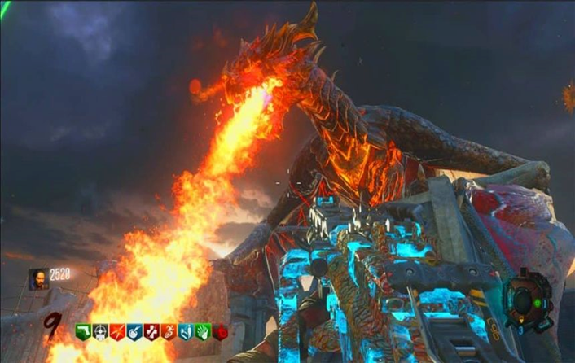

<https://gamezo.gg/6-best-call-of-duty-black-ops-3-zombies-maps/>

Major inspiration has been taken from call of duty zombies as this game heavily revolves around round-based mechanics. Waves of zombies attack the player, and the player must make choices such as what weapon to use, what perks to buy, and what strategies to use. Call of duty zombies has been a huge success and most importantly is fun to play and has unlimited re-playability.

The inspiration I have taken that I want to apply in Timeline Takedown is the round-based mechanic. I plan to have waves of enemies that attack the player, but unlike cod zombies there will be an end game that is not just dying from an overwhelming swarm of zombies.

* The Simpsons arcade game (1991)

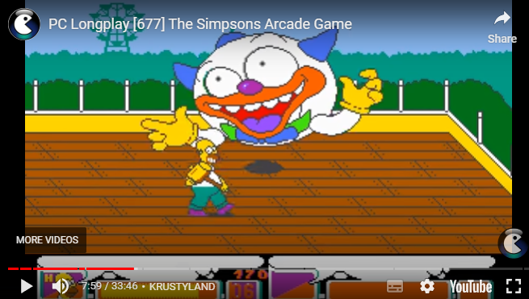

<https://simpsons.fandom.com/wiki/The_Simpsons_Arcade_Game>

       The Simpsons arcade game that released in 1991 is an action side scroller that is fun and nostalgic to play. The game featured many fan favourite locations and characters that players loved. It also included Themed combat immersion, for example the players would go to krustyland and fight a large circus krusty balloon, there would also be various enemies such as itchy & scratchy mascots to fight off.

       This type of themed combat is what I am taking inspiration from and implementing into Timeline Takedown. There will be unique location-based enemy's such as mummies in the pyramid levels, as well as dynamic environment interaction such as water effects when underwater.

**Player Experience**

* What should players feel when they play your game?

Players should feel like they want to play this game, not that it is a chore to do so. This will be achieved by making the gameplay fun and engaging, there will be challenging moments in this game but nothing that will deter the player from wanting to play.

**Platform**

* This will be a PC game that will be available for download on itch.io and possible future plans for a steam release.

**Software**

* This game will be built using the Unity game engine
* Inkscape will be used for creating UI elements such as menus and HUD items
* Animations will be done in unity
* Modelling and Texturing will be done using Blender or Unity
* Asset stores may be used to obtain certain assets/models

**Genre**

* Due to this game being a wave-based shooter and because the player will be playing in first person, Timeline Takedown will be under the Frist person shooter genre.

**Target Audience**

* The target audience for Timeline takedown is aimed at players who enjoy fast-paced, wave-based combat, and immersive, action-oriented experiences, particularly those who appreciate replayability and First-Person shooter games.
* The typical player for timeline takedown will fall within the age range of [16-35 years](https://ukiepedia.ukie.org.uk/index.php/Player_Diversity_%26_Demographics), they will be predominantly [male](https://ukiepedia.ukie.org.uk/index.php/Player_Diversity_%26_Demographics) and be majority located in North America, Europe and parts of Asia where the FPS genre is [highly popular](https://ukiepedia.ukie.org.uk/index.php/Player_Diversity_%26_Demographics).
* The typical player will be someone who enjoys the thrill of fast-paced action, values replayability, they will often enjoy the process of mastering mechanics, optimising strategies and competing with themselves or others to achieve higher scores or faster completion times(speedruning).
* The typical player will be curious/ take an interest in history as Timeline takedown will feature historical settings such as location, enemies and weapons.
* The target audience is already playing games withing the FPS and survival genre, key titles that they will have already played can include:

Call of Duty Zombies:

Players who enjoy this game are familiar with round-based wave survival modes, Timeline Takedown takes inspiration from that structure, with the added twist of unique historical settings and boss battles.

Killing Floor 2

Fans of killing floor 2 will appreciate the survival aspect, with waves of enemies becoming progressively harder, requiring both skill and strategies to advance.

Left 4 Dead 2

Players who enjoy Co-op survival games will find the appeal in Timeline Takedowns potential for a co-op mode, fighting of waves of location-themed enemies, similar to the squad-based combat in Left dead 2.

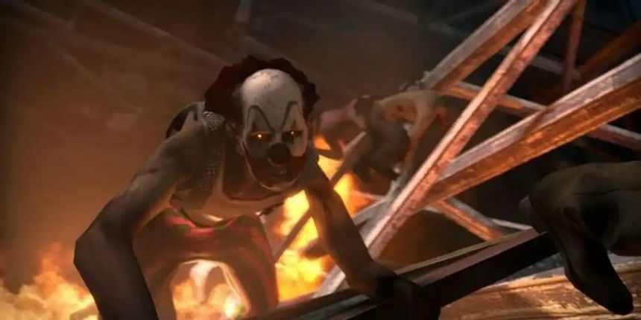

(Left 4 Dead clown zombie) <https://www.thegamer.com/zombies-left-4-dead-2-ranking/>

**Concept**

**Core Loop**

* The core gameplay loop will be fighting waves of enemies until the enemies have been defeated and then a boss will spawn, once the player has killed the boss it will drop a part, and the player can progress onto the next level and repeat this loop.

**Themes**

* Time Travel (travelling to different eras/time periods)
* Survival ( different enemy types, terrain and combat)
* Historical combat (each level and boss reflect the combat style and creatures they will have to fight off, e.g. mummies in Egypt)
* Sci-Fi elements (Time travel)

**Primary Mechanics**

Player Properties

* Has 4/3/3 lives at initial startup (easy/normal/hard)
* Taking a hit from an enemy will cause the player to -1 life
* Can move forwards, backwards, right, left, jump
* Can pick up weapons to kill the enemies
* Can pick up items to regenerate lives
* Has a static starting position in each level
* Can pick up time machine part from death of boss(1 per level)

             Enemy Properties

* Takes 3-6 hits to be killed by player
* Takes -1 life from player each time is hit
* Come from spawn locations and targets players location
* Each level the enemy will have different skin/costume to fit the level
* 5 waves per level – 1st wave will have 5 enemies, 2nd will have 10, 3rd will have 15, 4th will have 20 and 5th will have 20 and a boss

UI Properties

* Menu screen with background, background music and level selection and difficulty choice (easy, normal, hard).
* Menu screen include settings, music on/off , sfx on/off
* Player UI in game will display health in form of hearts, equipped weapon name as well as number of bullets, and what number wave they are on/5
* Pause screen (continue , end game)
* Death screen (retry , Menu)

**Secondary Mechanics**

Weapon system

* Players will have access to a range of weapons that can be collected throughout the levels. (Bows, Spear, other weapons based on level)
* Players need to collect ammo drops to refill their weapons if they are running low on ammunition, these drops will fall from killing enemies

Power-Up Drops

* Power ups that drop during the process of player killing an enemy, these drops will be Ammo Refill  and Speed boost, with the possibility of more being implemented in the future

Environmental interactions

* Each level will include elements that the player can interact with, these will mostly be doors to open and close and chests that can hold power drops or a weapon

**Tertiary Mechanics**

Co-Op Mode

* Players can team up split screen with their friend to enjoy the game, additional mechanics may need to be added for this game mode such as:

Reviving : Hold down “E” for 5 seconds on the players body to bring back the player if they get killed

* Increase Difficulty: If 2 players are going to play the number of enemies will need to be scaled up so there is still a challenge, additionally enemy health should be scaled up too.

Player Skins

* This is depending on if there is enough time to implement but I want to make beating levels unlock different player skins that they can equip as this will give players a reward for completing levels.

**Combat**

Ranged combat – ranged weapons such as throwing spears, pistols, pirate flintlock pistols and more will be the main way to defeat enemies. Each weapon will have a different firing style such as semi auto, full auto etc.

**Quests**

The main quest of this game will be to collect time machine parts from the different levels across the game, each time the player completes a level they will be rewarded with a part for the machine that progress towards the completion of the game

**AI / NPCs**

Enemy AI

* Enemies will have simple but effective AI behaviour. They will focus on targeting the player, and their difficulty will scale based on the number of waves or the level's progression. Enemies will use direct routes to the player but will also swarm from multiple directions, forcing the player to constantly reposition and strategise.

Boss AI

* Bosses will have a more complex AI, using specific attacks and gaining the ability to regen health. They will also have a significantly higher amount of health, making them harder to kill.

**Progression**

* The players main progression path is to collect all parts of the time machine by completing and defeating each levels final boss.

If there is enough time during game development I want to add the following progression features:

Levelling system

* Players earn experience points (XP) by defeating enemies and bosses, which can be used to level up and unlock new abilities or perks, such as increased health, damage resistance, or unique weapon skills.

Unlockable Cosmetics

* Progression unlocks new weapons, and skins. Players are rewarded for completing levels on higher difficulties or achieving specific milestones, such as killing a boss within a time limit or completing a level without losing any lives.

**Story**

**Narrative**

* This game revolves around a teenager who was teleported back in time after a failed science experiment on creating a concept on how a time machine would work, worked!

However, he soon realises that the time machine has taken him to an unknown timeline where everything is trying to kill him and there are no humans. He must defeat these enemies in order to obtain parts for assembling a teleporter in hopes he can teleport back to his timeline, but he is unsure if this will work.

**Characters**

Main Character (Player)

PHOTO(pending)

Name: Aaron Anderson

Description: Aaron is a 19-year-old male student who studies at the university of Bristol. He is studying science, and he is very smart, he spends his free time hanging out at pubs playing pool and having a few pints with his mates. Aaron shares a flat with his best mate Rick and has a crush on his neighbour Freya who also studies science. Aaron is hoping to impress Freya with his science project for the upcoming science fair as she is a big fan of the theory of time travel.

Secondary Character (Player 2)

PHOTO(pending)

Name: Rick Rossel

Description: Rick is Aarons best friend and his flatmate. He is 20 years old and works full time as a delivery boy. Rick is dopier and can often been spotted at the pub with Aaron or chilling in the flat playing video games. He is good friends with Freya as Rick is dating her older sister and Aaron is always asking for rick to put a good word in for him. Rick and Aaron have a brother type friendship and would do anything for each other.

Side Character (Unplayable character)

PHOTO(pending)

Name: Freya

Description: Aarons love interest, Ricks girlfriend’s younger sister.

Villains:

PHOTO(pending)

Name: Mummy

PHOTO(pending)

Name: Tutankhamun

PHOTO(pending)

Name: Skellington

PHOTO(pending)

Name: Dead Diver

More Villains are going to be incorporated once development starts

**Dialogue**

* When playing solo Aaron will make comments to himself like “I recognise this place”, referring to the locations he will find himself in. And comments such as “I don’t feel too good” when he is low on health or “crap! I’m almost out of ammo” if he on his last magazine.

* When playing co-op Aaron and Rick will say dialog to each other such as “how did we end up  in this mess” and “Look Out!” if the new wave has just started spawning. Rick may also be banterous with Aaron in situations when Aaron kills a boss by saying things like “I’m definitely telling Freya about this if we live to tell it”.

**Art**

**Design**

* The art style for Timeline takedown will embrace a Low-Poly aesthetic, similar to games like The legend of Zelda: BoW. This approach allows for a vibrant look that balances simplicity with charm.

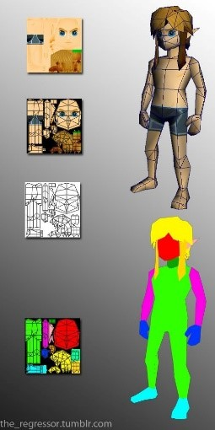

* Concept art

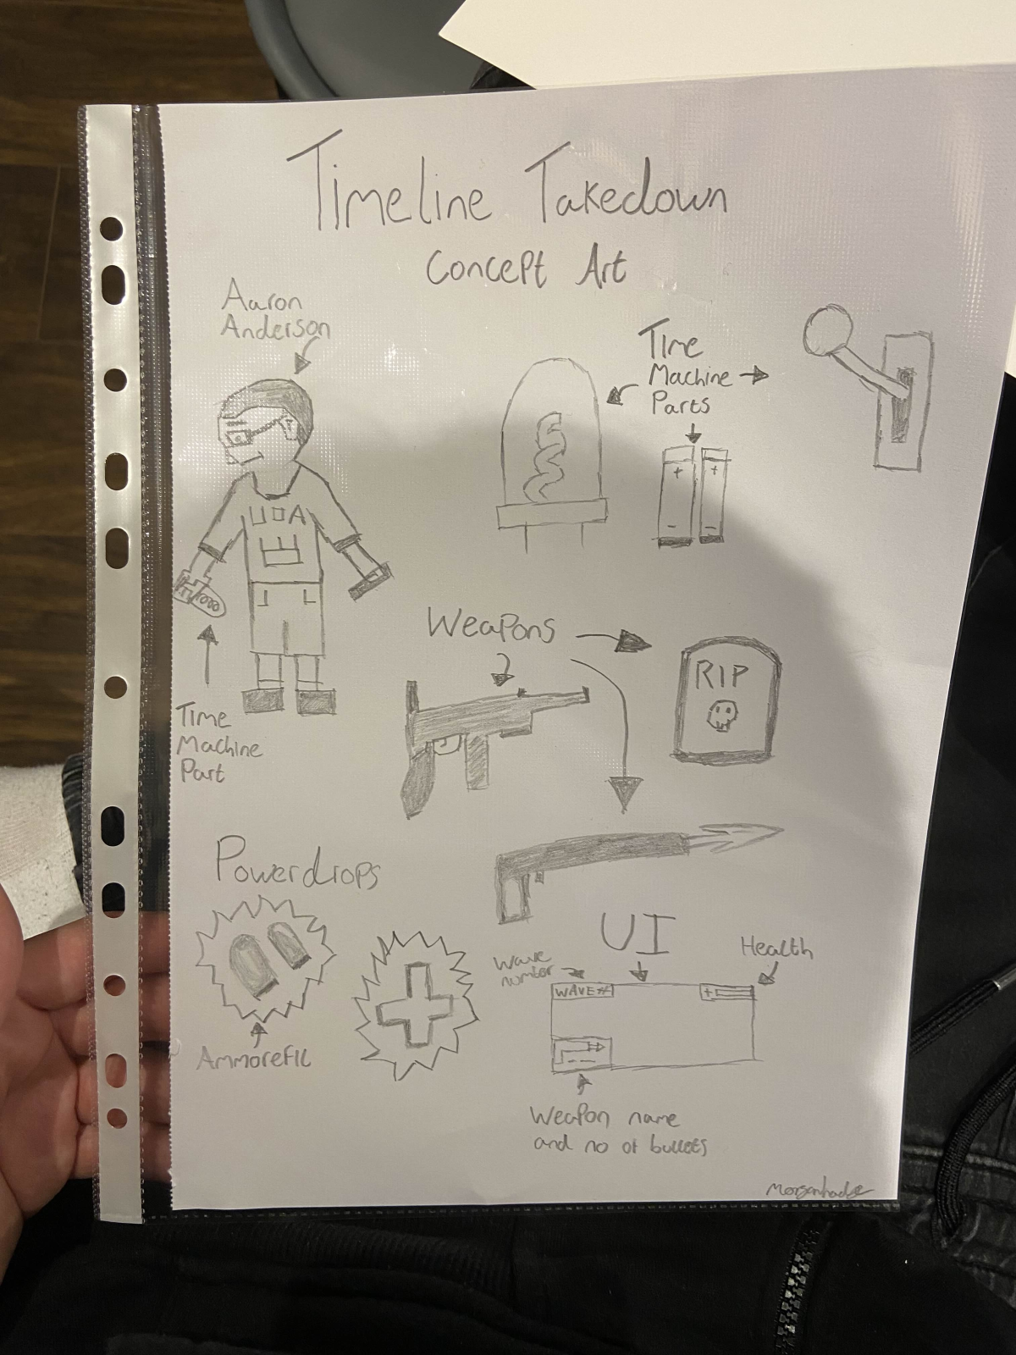

* Character designs

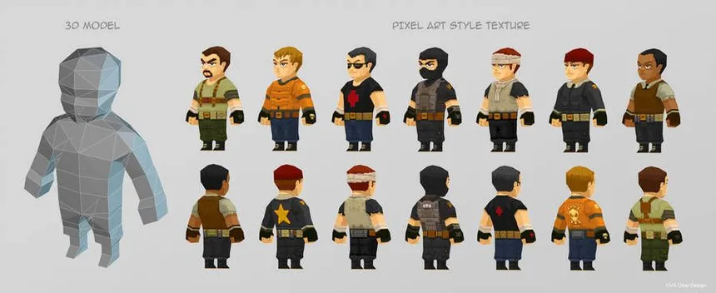

Src: [https://nz.pinterest.com/brianpnz/low-poly-characters/](https://nz.pinterest.com/brianpnz/low-poly-characters/" \t "_blank)

The 3D character models in Timeline Takedown will be similar to the above image, the art style will also be similar, but not as pixel art.

Enemies will feature playful, low-poly designs with thematic elements representative of their historical context (e.g a mummy with wrappings, a pirate with a tattered hat). The diversity of enemy designs will help emphasise the game's variety.

* Level designs

Each level will be carefully crafted to reflect its historical setting while maintaining a cohesive low-poly aesthetic. Environments will be rich with colour, detail, and dynamic elements, such as destructible objects or interactive features (e.g., hidden areas, environmental hazards such as traps in the pyramid).

**Visual Effects**

* Particles

Particle effects will enhance gameplay with visual flair. This includes muzzle flashes for weapons, explosion effects for defeated enemies, and environmental effects like dust clouds and splashes in water

* Character damage

When the players get damaged, blood splatters will appear on screen to reflect the fact that the player is losing health

**Lighting**

* Texture mapping,

Textures will be created to fit the low-poly style, focusing on vibrant colours and clear patterns that enhance the cartoonish feel. Each texture will reflect the materials found in historical settings, such as stone, wood, and metal.

* Dynamic lighting

Dynamic lighting will play a crucial role in setting the atmosphere in different levels. For instance, levels may have shifting light sources to create tension (e.g. flickering torches in a dark pyramid) or to highlight specific areas (sunlight streaming through the wreck of the Titanic)

**Animation**

* Character animation

Combat and movement animations will include a range of actions such as running, jumping, walking , shooting and reloading

* Enemy animation

Enemy animation will reflect their unique identities, with movements that align with their historical theme. For example, mummies may have a slow shuffling movement, whilst Skellington’s in the titanic wreck will be able to move swiftly and jaggedly

* Environmental animation

Level environments will include animated elements such as moving water, swaying plants, and environmental effects (e.g., clouds passing overhead or fire flickering on torches) to bring the world to life and create an immersive atmosphere

**Audio**

**Music**

* There will be background music playing throughout the menu screen and more tense background music during the gameplay. The music that will be used is unconfirmed as of right now and will be acquired from a free online music site such as [cloudcovermusic](https://cloudcovermusic.com/choosing-music-guide/background-music-for-video-games) or [chosic](https://www.chosic.com/free-music/games/).

**Sound Effects**

There will be sound effects for:

* Inflicting damage
* Receiving damage
* Movement
* Interactions such as picking up parts and items
* Enemy growling/snarling
* Dying
* Completing level
* Environmental noises ( wind, water, fire, etc)

These sound effects will be acquired from various online sites such as [Mixkit](https://mixkit.co/free-sound-effects/game/), [Pixabay](https://pixabay.com/sound-effects/search/game/), [Free sound](https://freesound.org/browse/tags/game-sound/),  [Opengameart](https://opengameart.org/content/library-of-game-sounds) and more.

**Voice Acting**

* The voice acting will be conducted by myself morgan hodge for Aaron and my housemate David Penfold will voice Rick. We will both sit down in my room with the voice lines written out on screen and record all the segments. I will use my Razer Seiren Mini for the voice recordings. The audio will be edited and exported into individual mp4 files using the [Audacity](https://www.audacityteam.org/) free audio editor software.

**Game Experience**

**UI / UX**

The user interface and User Experience design of Timeline Takedown is created to ensure an ease of use while maintaining a fun and immersive experience in the game’s world.

**Controls**

* Keyboard and mouse Inputs

|  |  |  |
| --- | --- | --- |
| **ID** | **Key(s)** | **Action** |
| 1 | W | Move Forward |
| 2 | A | Move Left |
| 3 | S | Move Backwards |
| 4 | D | Move Right |
| 5 | R | Reload weapon in hand |
| 6 | Spacebar | Jump |
| 7 | E | Interact with object |
| 8 | Esc | Open Menu |
| 9 | Leftclick | Aim |
| 10 | Rightclick | Shoot |
| 11 | Scroll Wheel/ 2 | Switch to secondary weapon |

              Controller Inputs

|  |  |  |
| --- | --- | --- |
| **ID** | **Key(s)** | **Action** |
| 1 | Left Stick Up | Move Forward |
| 2 | Left Stick Left | Move Left |
| 3 | Left Stick Down | Move Backwards |
| 4 | Left Stick Right | Move Right |
| 5 | X Button | Reload weapon in hand |
| 6 | Spacebar | Jump |
| 7 | Hold X Button | Interact with object |
| 8 | Start Button | Open Menu |
| 9 | Left Trigger (LT) | Aim |
| 10 | Right Trigger (RT) | Shoot |
| 11 | Y Button | Switch to secondary weapon |

**Menus**

Intuitive Menus

* All menus are designed for smooth navigation, providing players with easy access to essential options such as starting the game, choosing levels, adjusting difficulty, and toggling sound settings. Fonts and menu layouts are chosen to fit the historical and sci-fi themes of the game, with a clean and immersive visual style.

The main menu will consist of sub-menus that include:

* Start Game
* Options
* Quit
* Level Selection
* Pause Menu
* Restart Level
* Quit to Main Menu

Minimalist In-game HUD

* Health, represented visually by hearts or a bar that depletes with each hit
* Weapon Status, shows the current weapon and ammo count, ensuring players can keep track of their resources without breaking focus
* Wave Tracker, A small indicator in the corner displays the current wave number and total waves for the level

Contextual prompts

* In-game prompts appear only when necessary, such as when near an interactable object or collectible. This keeps the player focused on action without overwhelming them with constant pop-ups

**Market Requirements**

**Priorities:**

* Must Have :
* Functional wave-based combat system with enemies and bosses
* Historical themed levels with unique enemies and environments
* Basic UI – Health display, ammo, wave counter, etc)
* Player movement and combat mechanics( movement, shooting, enemy targeting)
* Basic level progression with the time machine parts and boss fights

* Should Have :
* Multiple difficulty settings( easy/normal/hard)
* Weapon variety (different weapons)
* Power Ups
* Sound Design that matches the map theme

* Could Have:
* 2 player CO-OP
* Boss-Specific mechanics that vary depending on location (special attacks)
* Cosmetic customisation for player model and weapons
* Player level progression

* Want to Have:
* More than 3 or  levels, possibly up to 10
* Online support for friends to play over the internet
* Hidden challenges/missions (easter-eggs)

**Minimum Viable Product**

* Basic combat mechanics, Players can engage in waved-based combat, defeating enemies and collecting time machine parts
* Level progression, at least three historical levels (e.g, Egyptian pyramids, Titanic wreck, Roman colosseum), each with unique enemies and a boss.
* Weapon and item pickups
* UI elements, health bar, ammo count, wave number and a simple pause menu
* Enemy AI, basic enemy movement and attack patters that increase in difficulty across waves

**Delivery**

* **Alpha Version (1-2 months**) internal testing of core gameplay mechanics (combat, levels, UI)
* **Beta Version (2-4 months**) Closed beta with most levels, enemies and functionalities, focusing on bug fixing

* **Final Release(4-6 Months)** Full game with MVP features, released on itch.io and potentially steam

**Post-Launch** 

* Feedback –

Monitor player feedback in the comment section of Itch.io and any comments left on the social media channels. Act accordingly upon this user feedback and reply to the comments that are left to show that feedback is being acknowledged.

* Bug Fixing -

Regular updates to fix any gameplay or technical issues encountered by player’s post-launch.

**Technical Requirements**

**Systems**

* Complex macro elements that need to be built and which require further depth and planning of their own

Health System:

Tracks player health, offering multiple lives and health regeneration items allowing for a fair challenge

Pathfinding systems:

For AI enemies, allowing them to navigate levels effectively, avoid obstacles and engage with the player

**Work Packages**

* Prototype pass – Develop a basic playable version of the core gameplay loop to test mechanics and ensure foundational systems work
* Gameplay pass – Focus on the combat mechanics, enemy AI, and player abilities based on feedback from the prototype
* Story pass – Integrate narrative elements such as the voice acting segments to ensure the story matches with the gameplay
* Polish pass – Fine-tune visuals, animations, and sound effects to create a polished product
* Release pass – Finalise all elements for the full launch, ensuring all systems and mechanics are stable and have been tested

**Tasks**

|  |  |
| --- | --- |
| Task Department | Task Description |
| Art and Design | Create Concept Art  Character Designs  Level Layouts |
| Programming | Implementation of core gameplay systems, AI behaviour and UI elements |
| Audio | Create Sound effects, background music and voice acting |
| QA | Testing gameplay, report bugs, test the overall quality of game |

**Activities**

A Trello board has been created to track and monitor progress : https://trello.com/invite/b/6713ecc23691aeb9441f3609/ATTIc3ced0c9049f3f63121cd6e4215eb400CDAFEF68/timeline-takedown

* Fortnightly meetings with project leader JJ are conducted to track and report progress. If there are any enquiries about the project they should be reported to JJ.

Thank you for reading – Morgan Hodge

## Appendix 2: Inkscape Designs

Inkscape was used to create a variety of assets for Timeline Takedown, such as canvases, UI elements, Powerups, Pause Menu, and more.

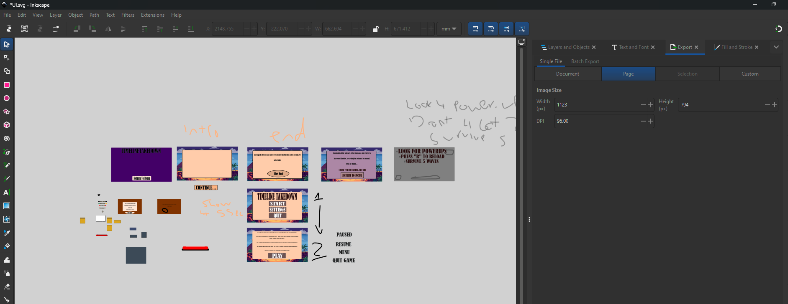

*Figure X : An overview of the UI page*

*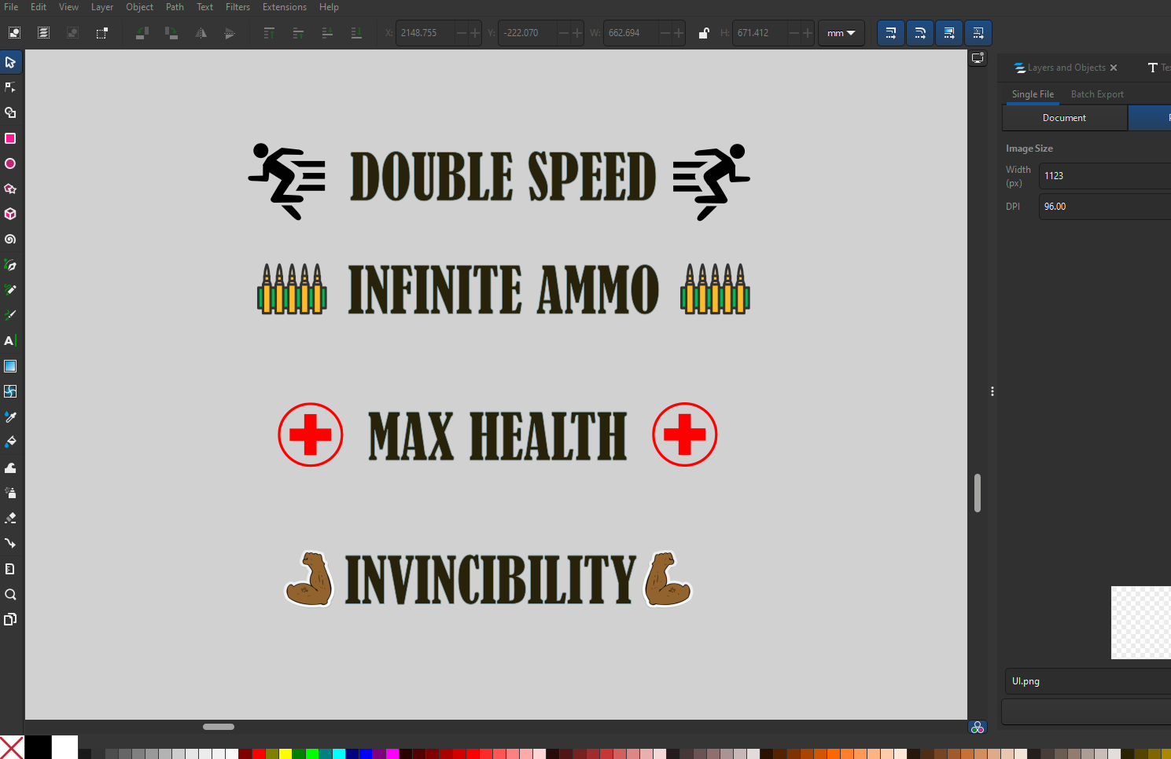*

*Figure X : PowerUp Messages*

*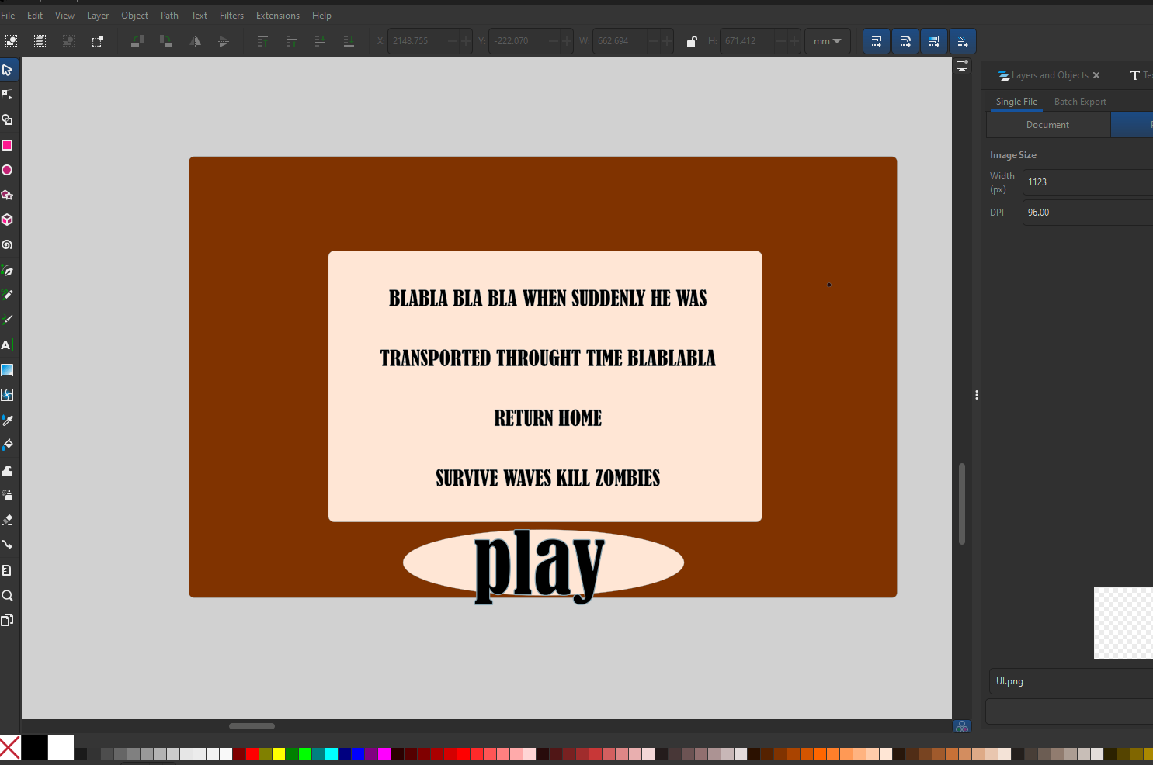*

*Figure X: Initial Start Screen idea*

*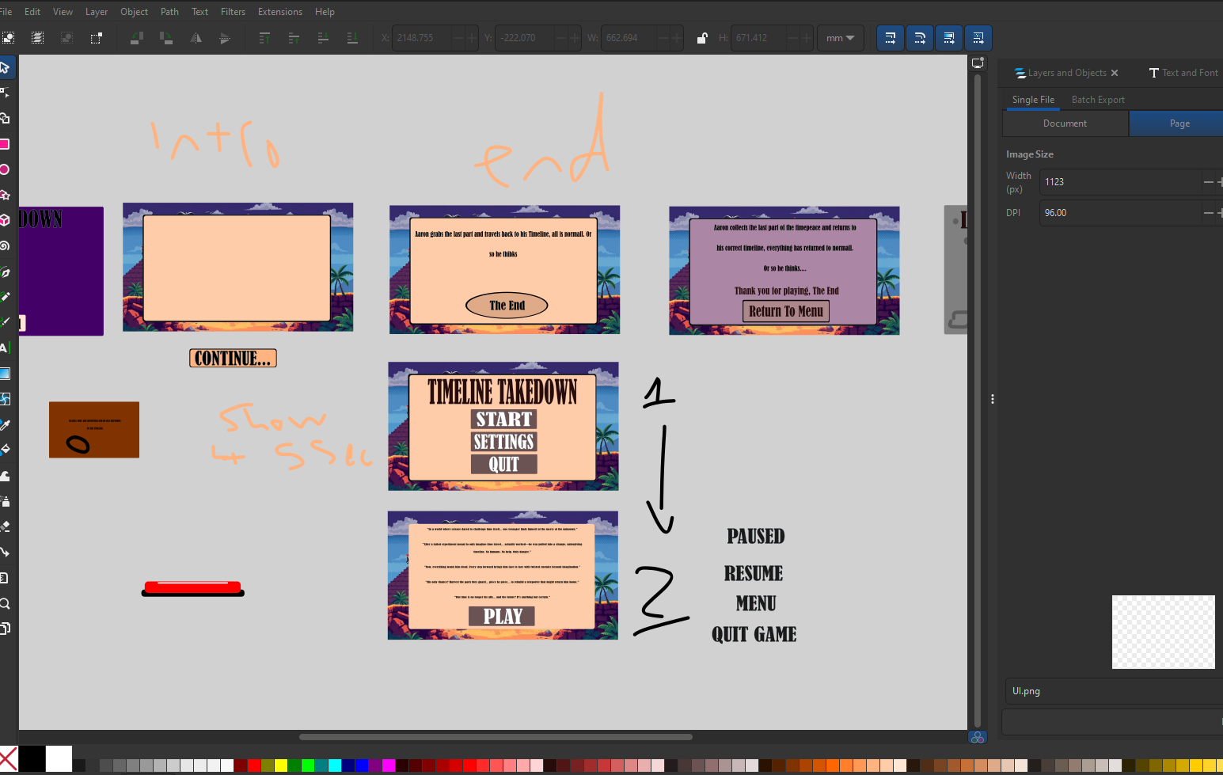*

*Figure X: Scene Flow Plan*

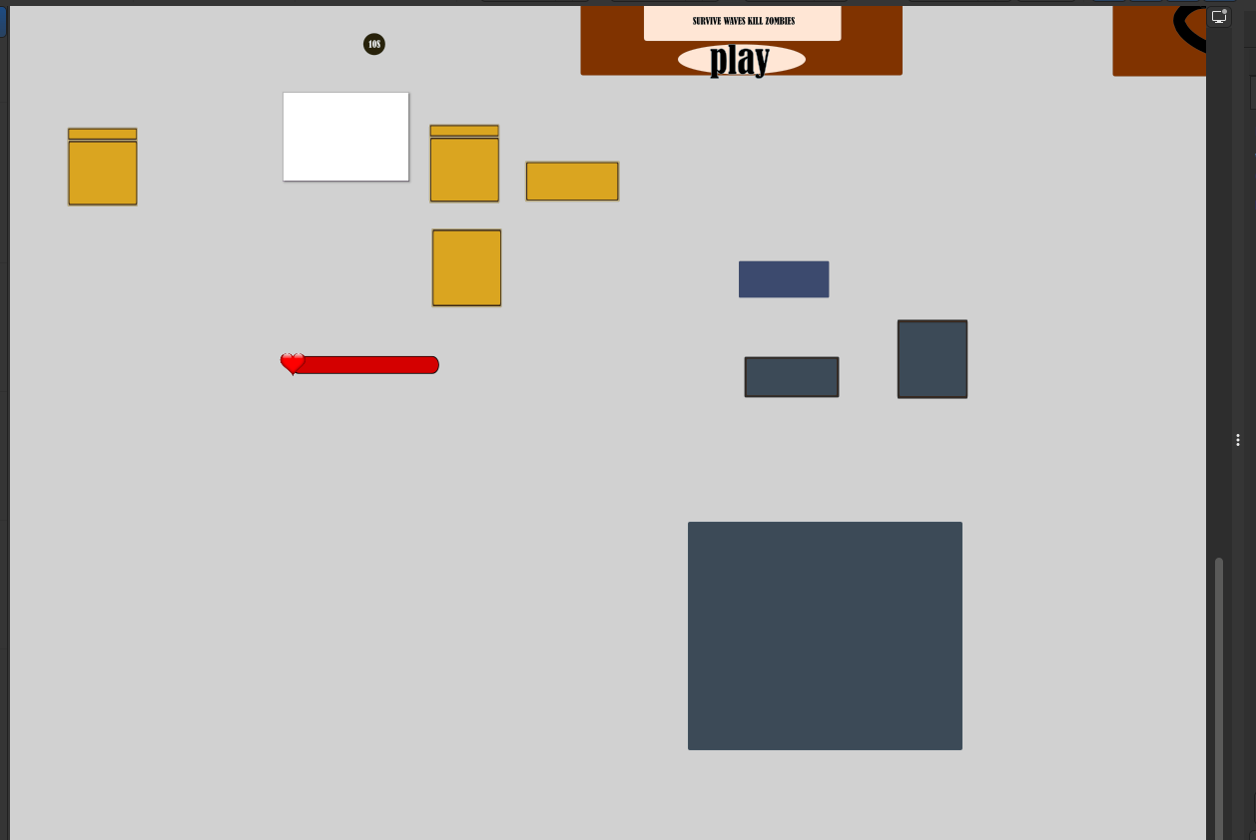

*Figure X: Boxes used for on screen UI such as ammo count and wave count*

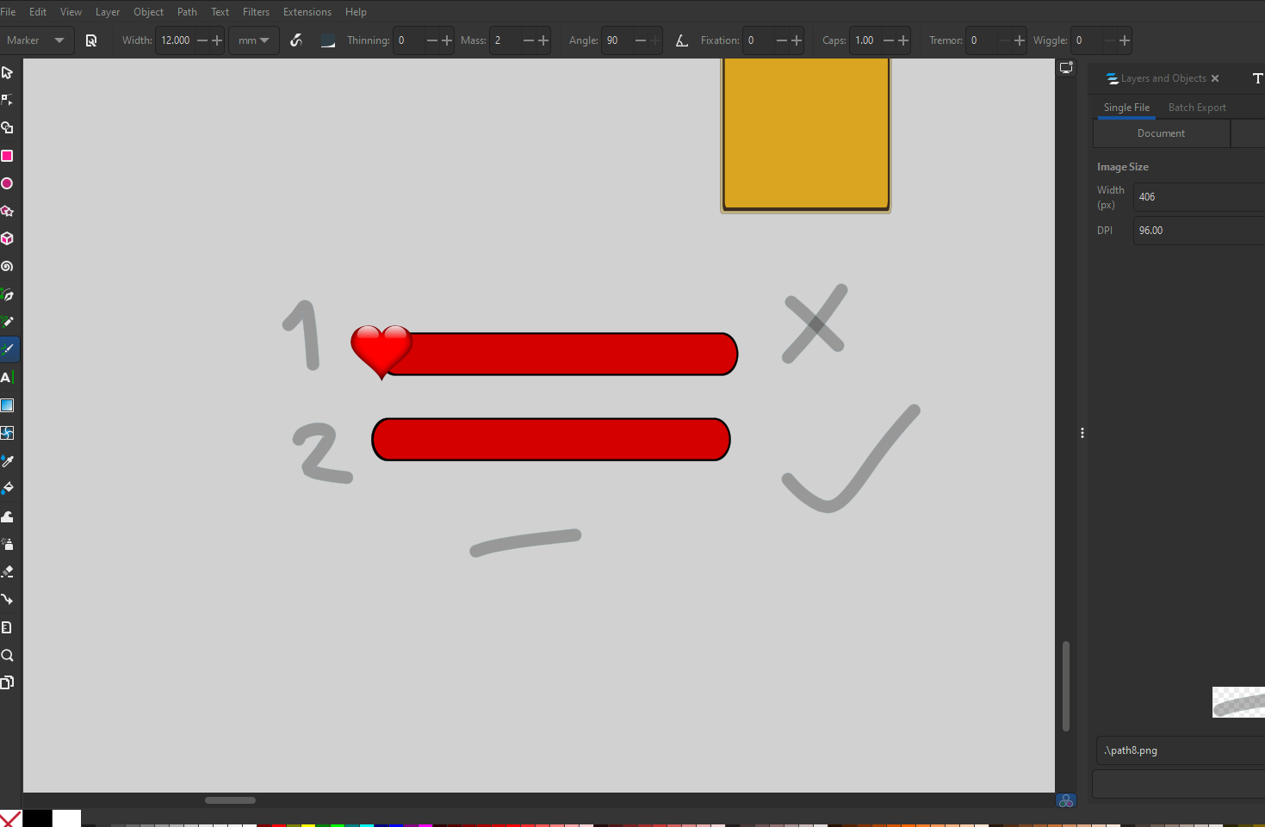

*Figure X: Health Bar*

## Appendix 3: Devlogs

Every Development Log recorded is below:

Devlog 1: https://youtu.be/Su4Demj-MFw

Devlog 2: https://youtu.be/RXlF7QE14os

Devlog 3: https://youtu.be/vxEHmGPZ-y4

Devlog 4: https://youtu.be/lJwd-J0-sTs

Devlog 5: https://youtu.be/2hVWVUD5KXo

Devlog 6: https://youtu.be/nWcjUrmOtSQ

Devlog 7: https://youtu.be/-r5FLIDuMCo

## Appendix 4: Dungeon Scrawl Designs

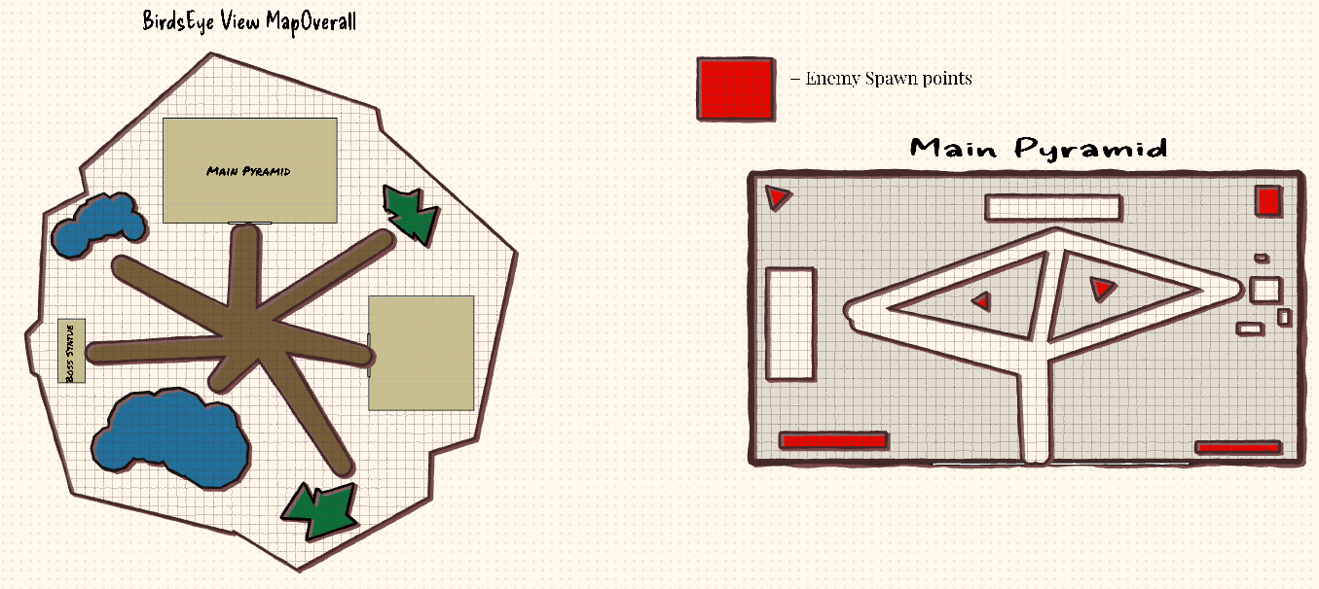

*Figure X: Level 1*

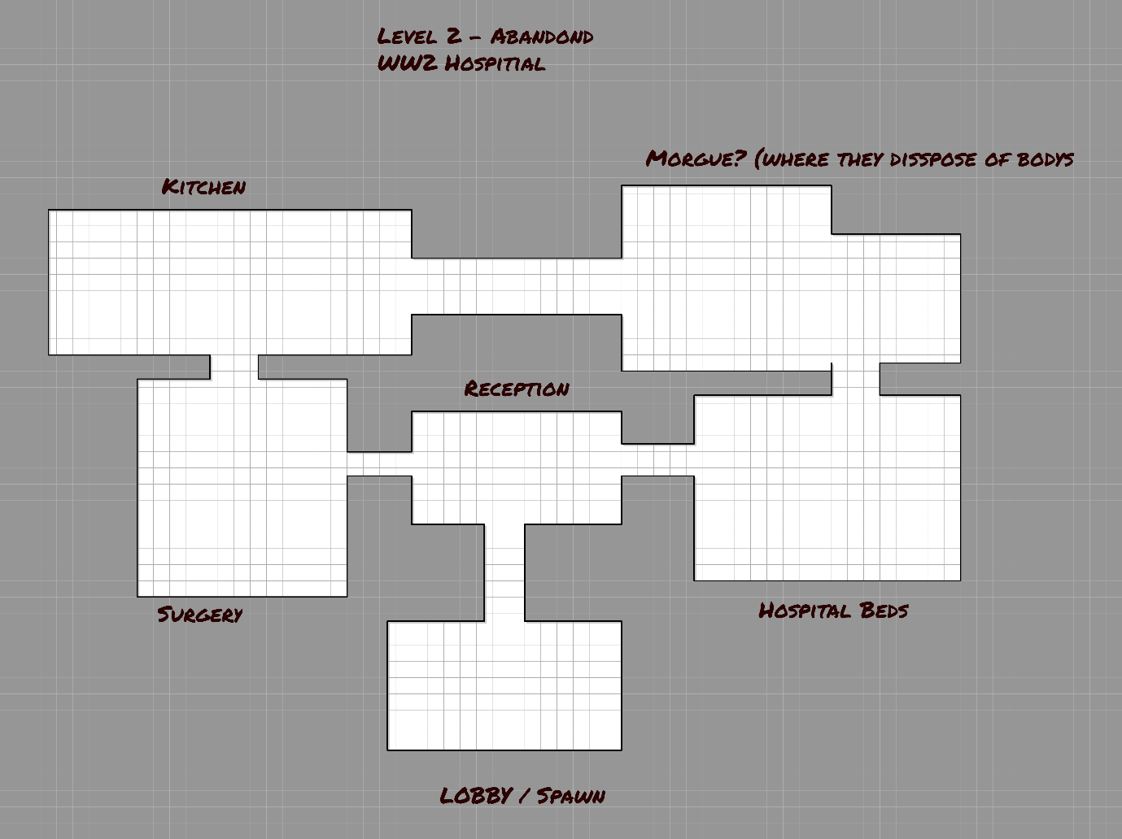

*Figure X: Level 2*

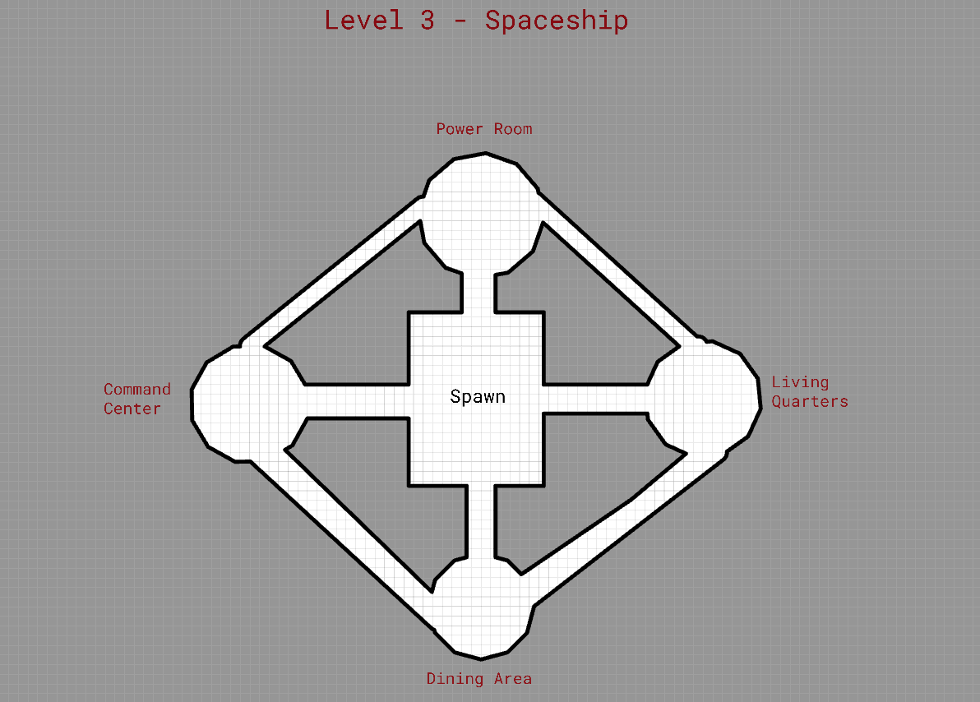

*Figure X: Unreleased Level 3 Plans*

## Appendix 5: Breakdown of technology and tools

### Hardware

Timeline Takedown was created on a PC that had the specs of:

* Intel i9 10900 CPU @ 2.80GHz
* NVIDIA GeForce RTX 2060 Super 8GB
* 24GB Ram

### Software

* Windows 11 Home
* Inkscape
* Dungeon Scrawl
* Trello
* YouTube
* Unity
* Itch.io
* Microsoft Forms

## Appendix 6: All paper designs

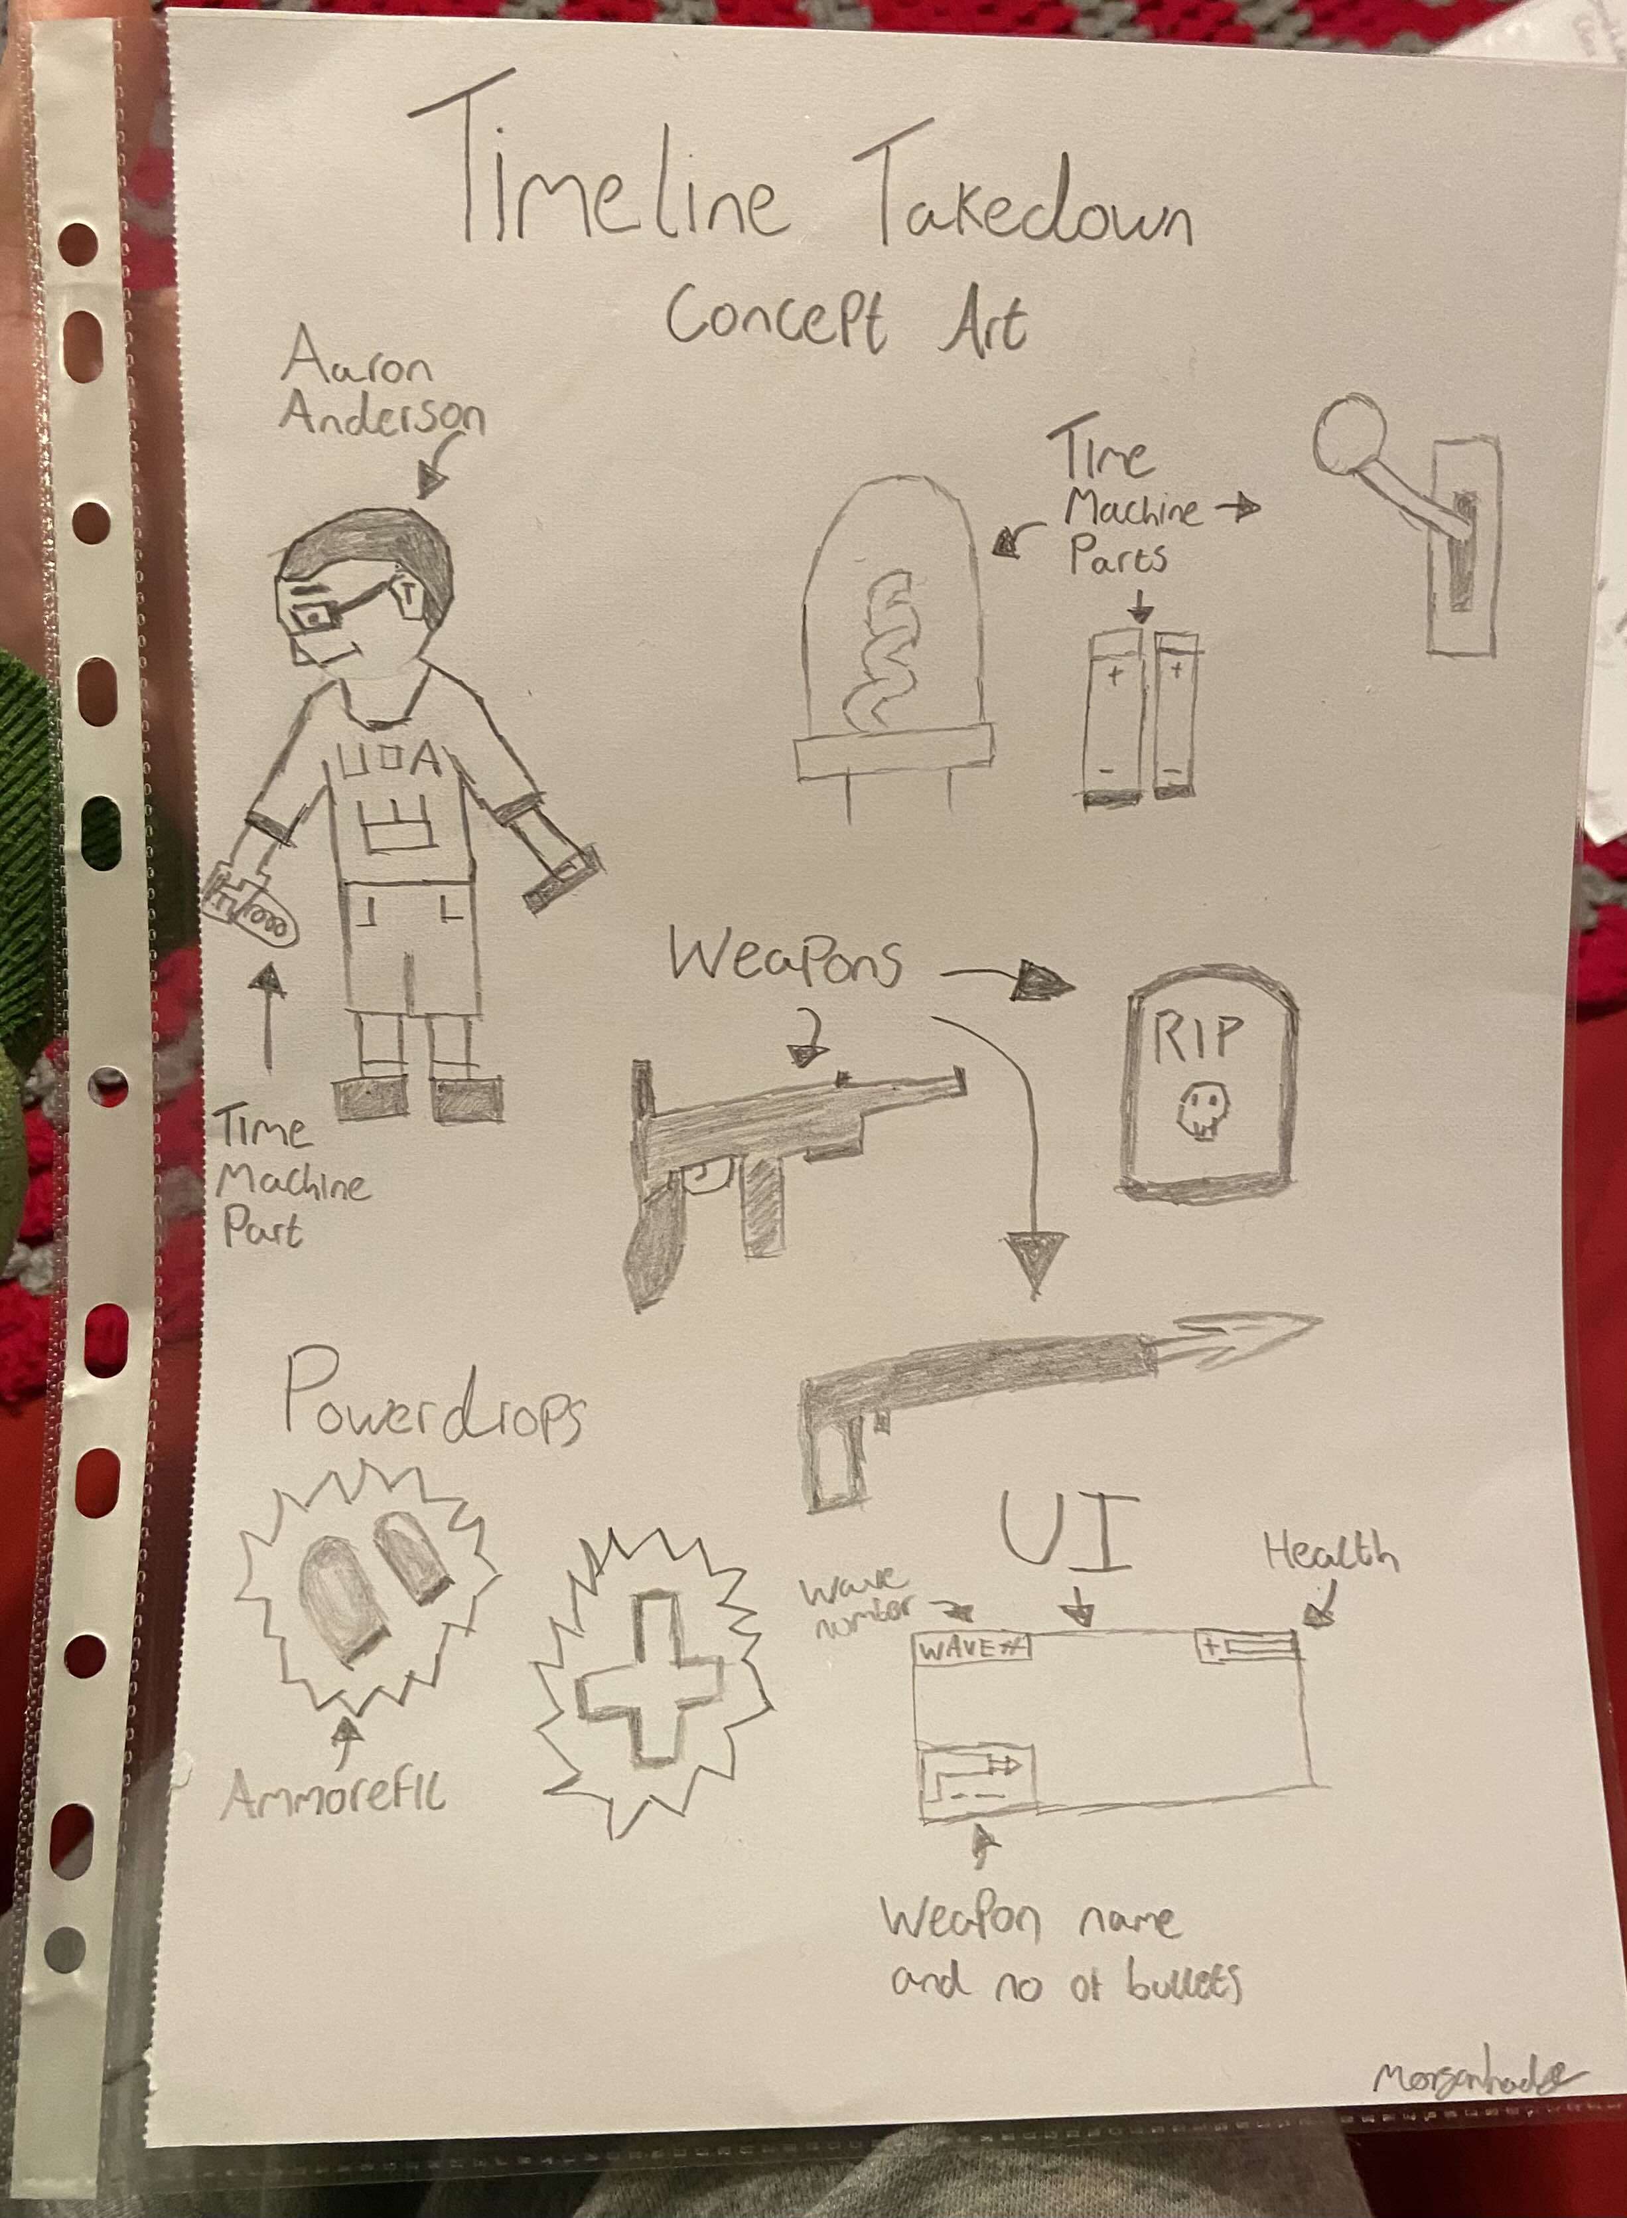

*Figure X: Concept Art for Timeline Takedown*

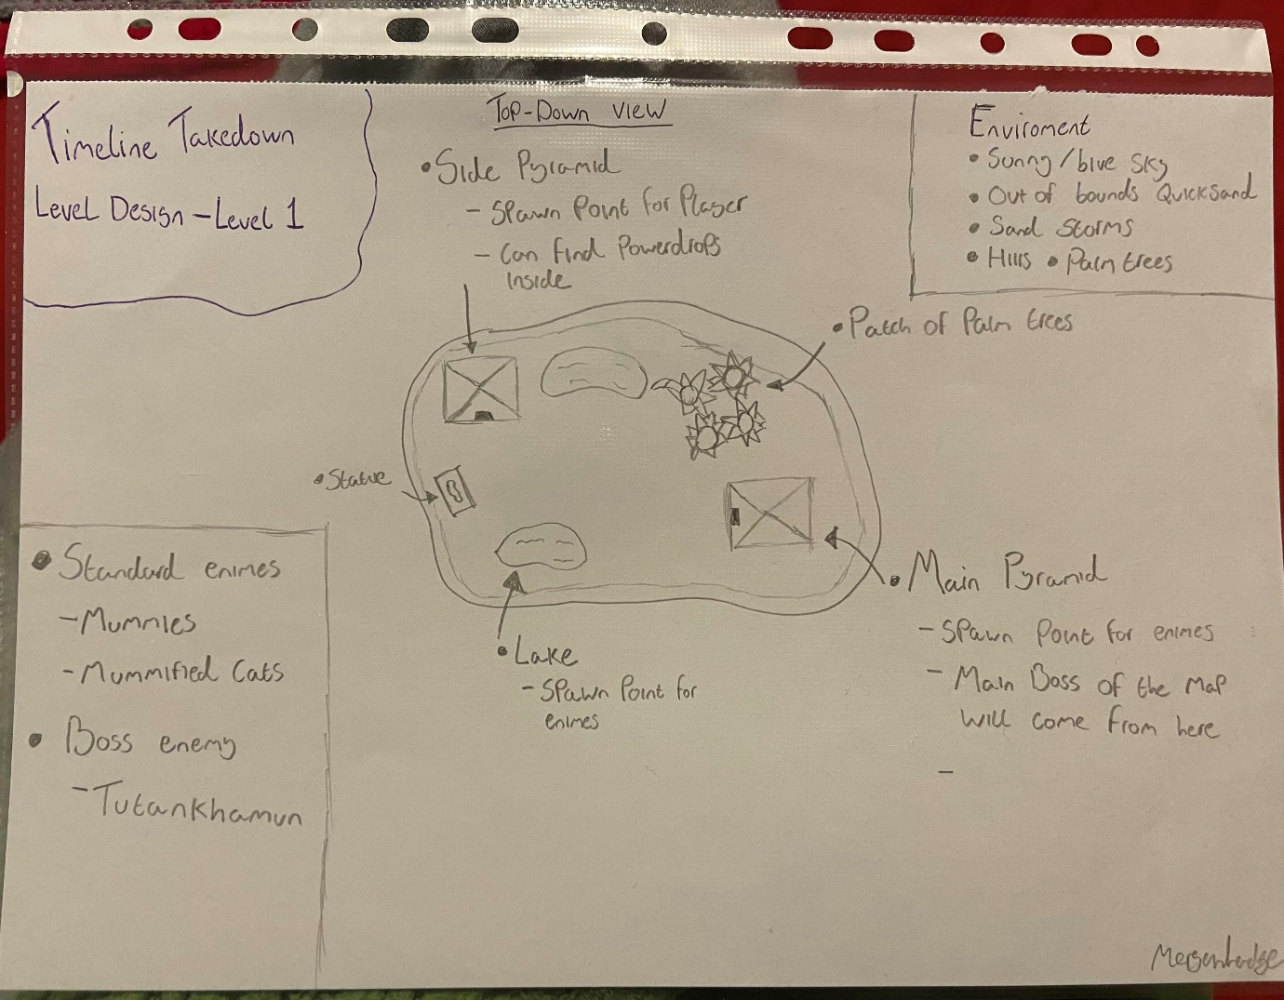

*Figure X: Level Art for Timeline Takedown Level 1*

*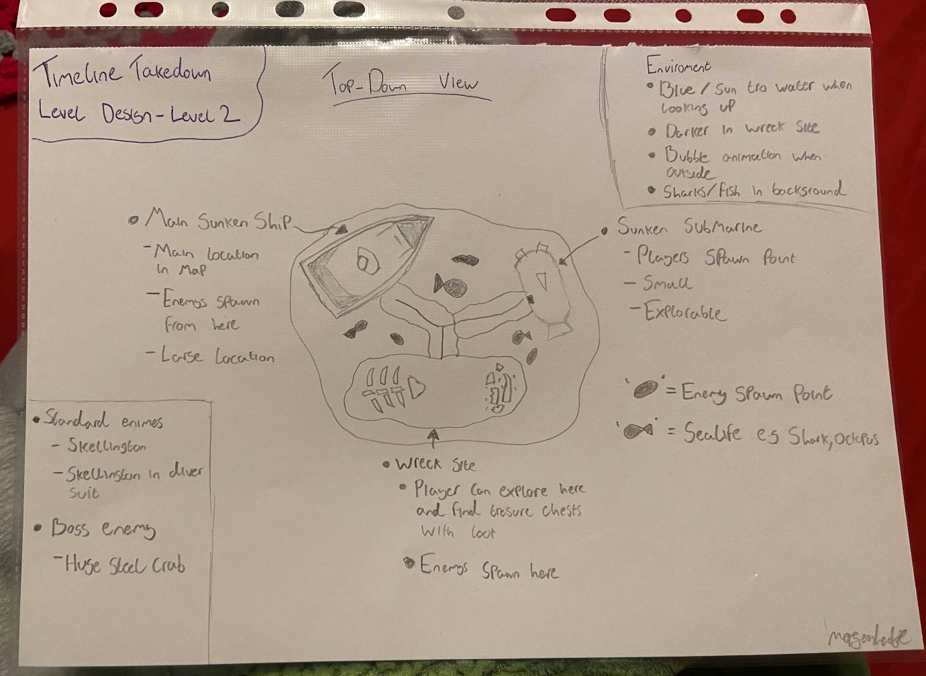*

*Figure X: Level Art for Timeline Takedowns scrapped Level 2*

## Appendix 7: Asset list

Please note that some of these assets may not have been used within Timeline Takedown and were simply noted as assets that have potential use for the future development.

Skellington : <https://assetstore.unity.com/packages/3d/characters/low-poly-skeleton-162347>

Nature pack: <https://assetstore.unity.com/packages/3d/environments/landscapes/low-poly-simple-nature-pack-162153>

Dungeon: <https://assetstore.unity.com/packages/3d/environments/dungeons/ultimate-low-poly-dungeon-143535>

Main character : <https://assetstore.unity.com/packages/3d/characters/humanoids/fantasy/free-low-poly-human-rpg-character-219979>

Guns: <https://assetstore.unity.com/packages/3d/props/guns/guns-pack-low-poly-guns-collection-192553>

Pyramid in this : <https://assetstore.unity.com/packages/3d/environments/landscapes/low-poly-atmospheric-locations-pack-278928>

Old weapons : <https://assetstore.unity.com/packages/3d/props/weapons/low-poly-rpg-fantasy-weapons-lite-226554>

Fantasy swords:   
<https://assetstore.unity.com/packages/3d/props/weapons/free-low-poly-swords-rpg-weapons-198166>

Power ups: <https://assetstore.unity.com/packages/3d/props/low-poly-powerups-212079>

Boss fight? : <https://assetstore.unity.com/packages/3d/characters/creatures/monster-4-low-poly-208684>

RealTimeCsg - <https://assetstore.unity.com/packages/tools/modeling/realtime-csg-69542>

Sand for terrain - https://polyhaven.com/a/sandy\_gravel\_02

BACKGROUND Music - <https://mixkit.co/free-stock-music/tag/futuristic/>

Fire - <https://mixkit.co/free-sound-effects/fire/>

Gun - https://mixkit.co/free-sound-effects/gun/

PNG - <https://www.cleanpng.com/png-war-robots-punisher-weapon-firearm-cossack-4573851/download-png.html>

Fonts - <https://www.dafont.com/theme.php?cat=101&page=9>

SFX - <https://pixabay.com/sound-effects/search/bones/>

<https://assetstore.unity.com/publishers/22224>

L2 Gun - <https://assetstore.unity.com/packages/3d/props/guns/low-poly-pistol-weapon-pack-1-285693>

L2 assets - <https://assetstore.unity.com/packages/3d/environments/urban/abandoned-asylum-49137>

<https://www.mixamo.com/#/?page=1&type=Character>

## Appendix 8: University Ethics Policy

The Ethics Policy that was followed can be found here: [Ethical Approval Summary.pdf](https://liveplymouthac-my.sharepoint.com/:b:/g/personal/morgan_hodge_students_plymouth_ac_uk/Ed2gowxGfCZGn7abPbPI4lgB_y5WkqXlQ2hbPjZnMdNHQw?e=zNQCy6)

## Appendix 9: Trello board

This includes my entire Trello board through screenshots, please note that I unchecked all the “Done” boxes as they had a grey tint when checked and I did not want them to be unreadable to the reader.

A link to the public board can also be found under Appendix 0: Links.

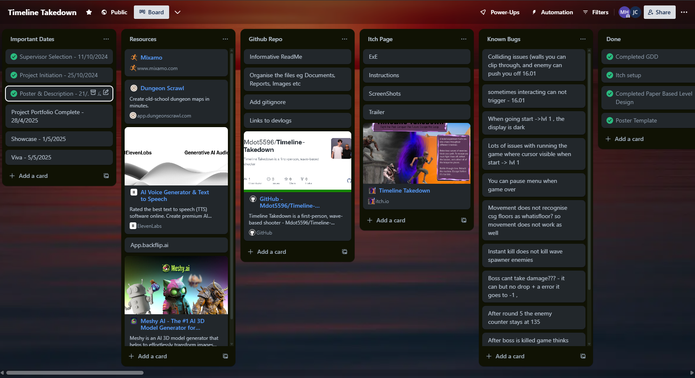

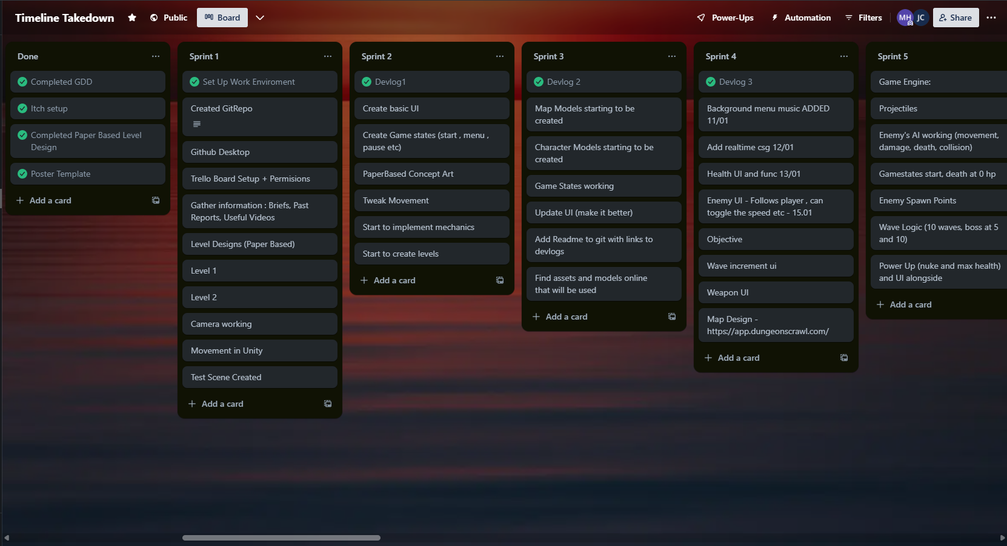

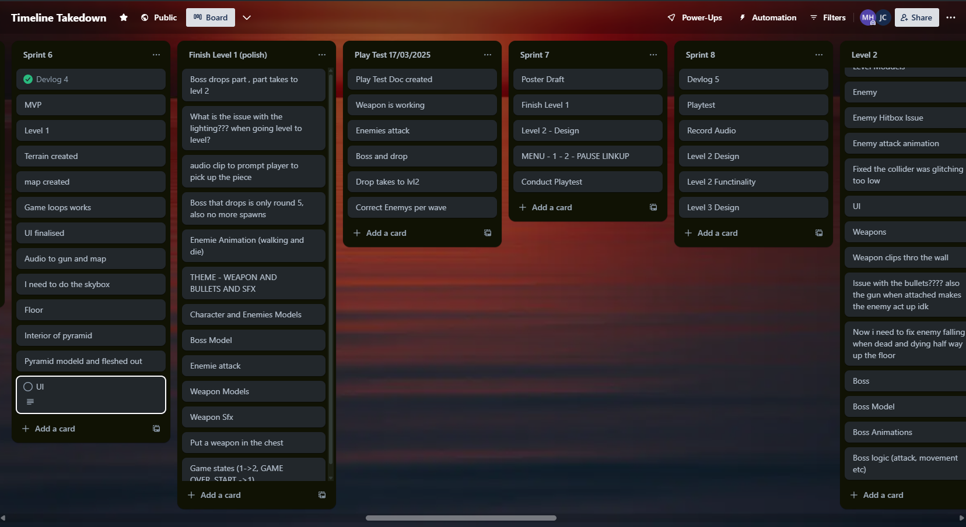

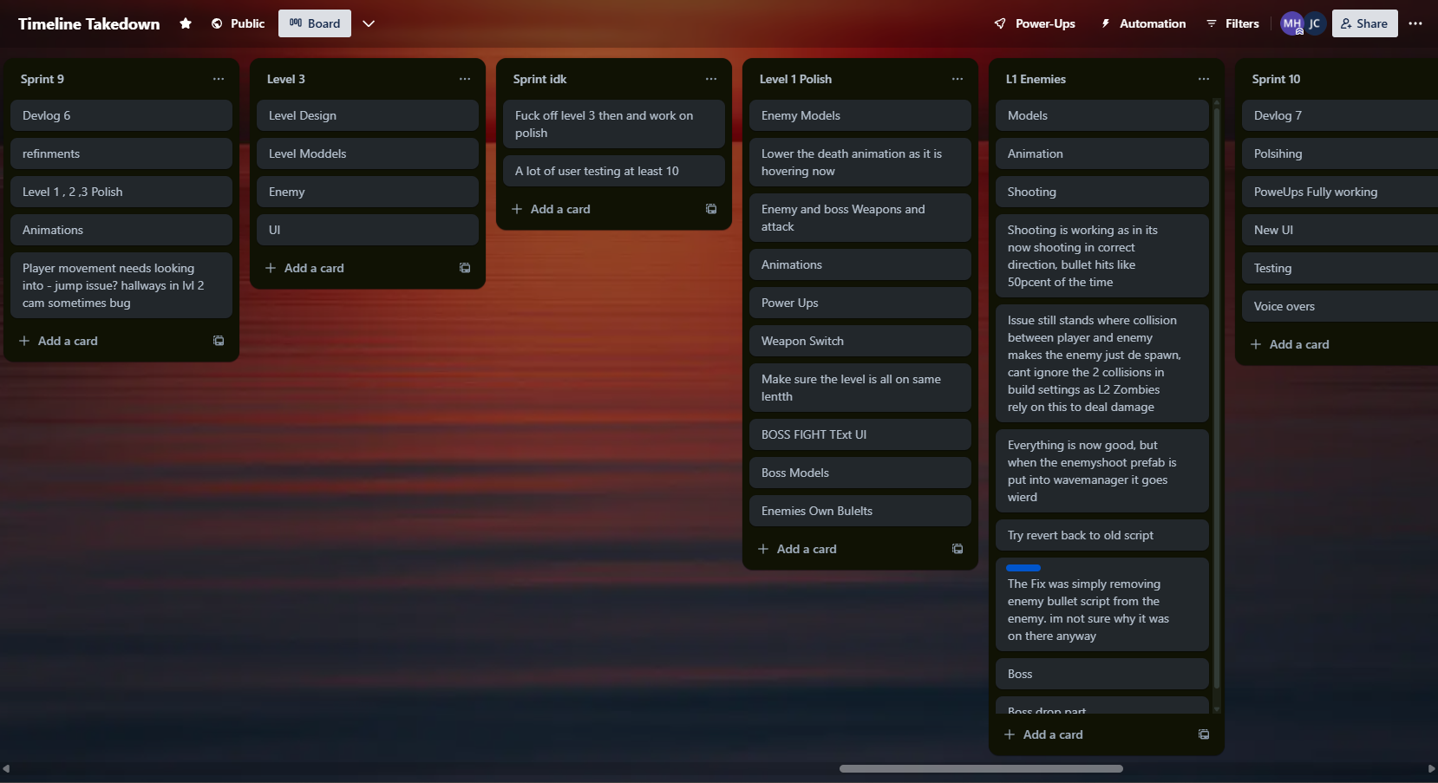

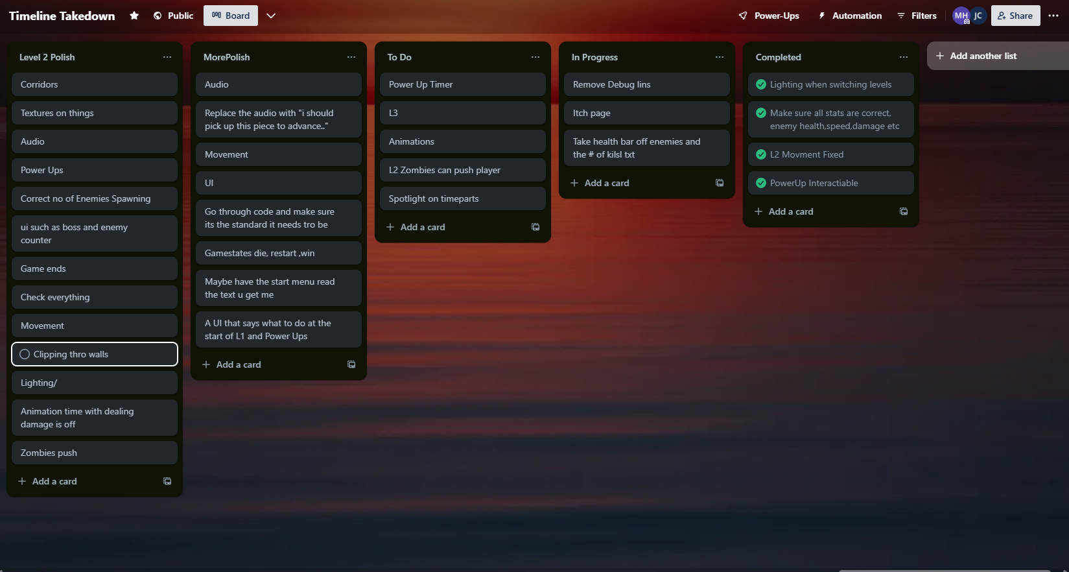

## Appendix 10: Testing

### Feature Testing and Sprint Testing:

Feature and sprint testing was often conducted by the developer, this meant there was often no professional testing plan as feature testing was conducted after every iteration and did not need to be recorded. However, there are still some documents that have collected notes from the feature testing , and other information that was noted during this testing throughout the project.

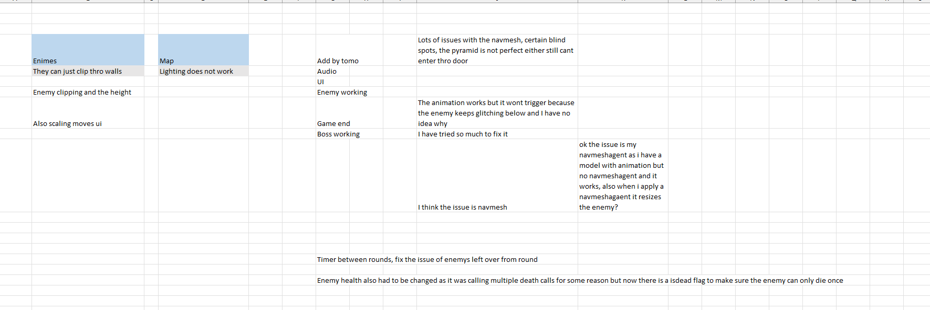

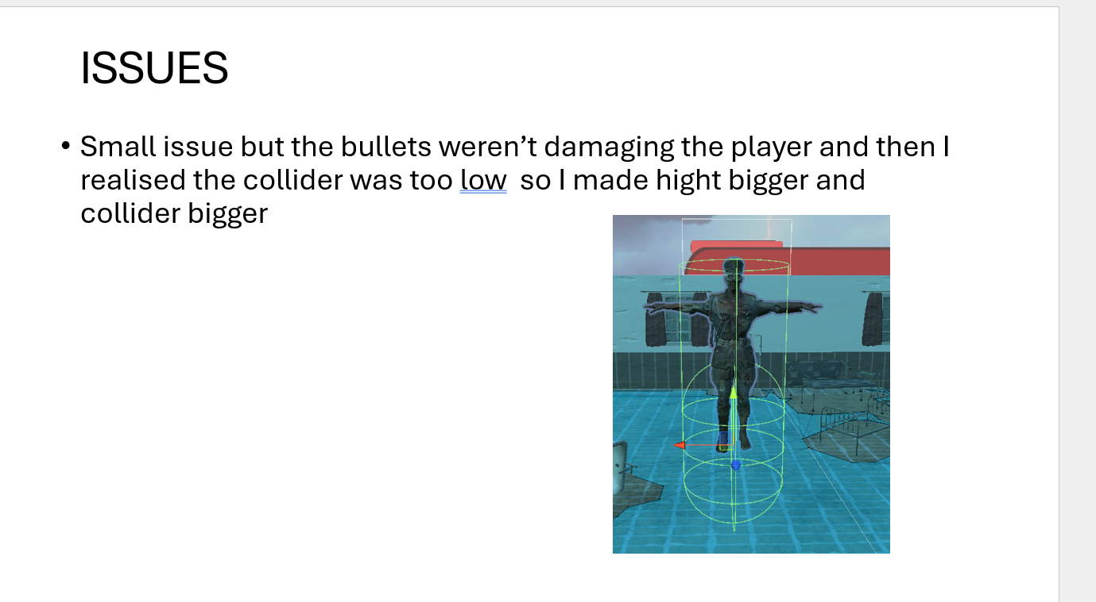

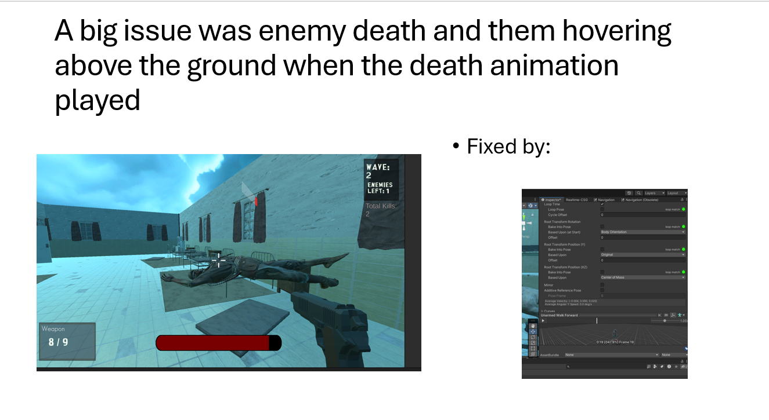

### User Testing:

The first iteration of user testing was conducted using Excel. This proved to be an ineffective method as the layout was unclear regarding what each question was asking of the tester. Additionally, the results section became cluttered and organised with responses being recorded directly next to the questions, allowing users to see each other’s answers. This compromised the anonymity and integrity of the feedback, this method was not used again. Below are screenshots of the initial testing documents:

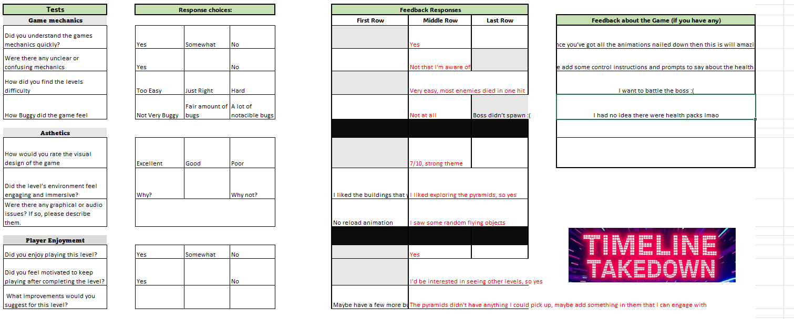

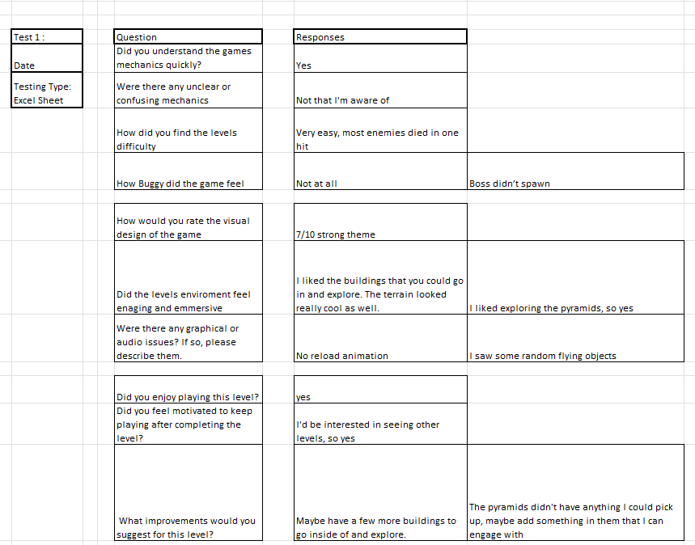

After this initial attempt I decided to change the approach. I created a questionnaire using Microsoft Forms. This method was significantly better, offering a clean and easy to understand layout. Testers were presented with predefined response options, eliminating confusion over where to input their answers. I found this platform far more professional and effective, and I continued to use Microsoft Forms for all subsequent user testing throughout the project. Below are screenshots of the Forum:

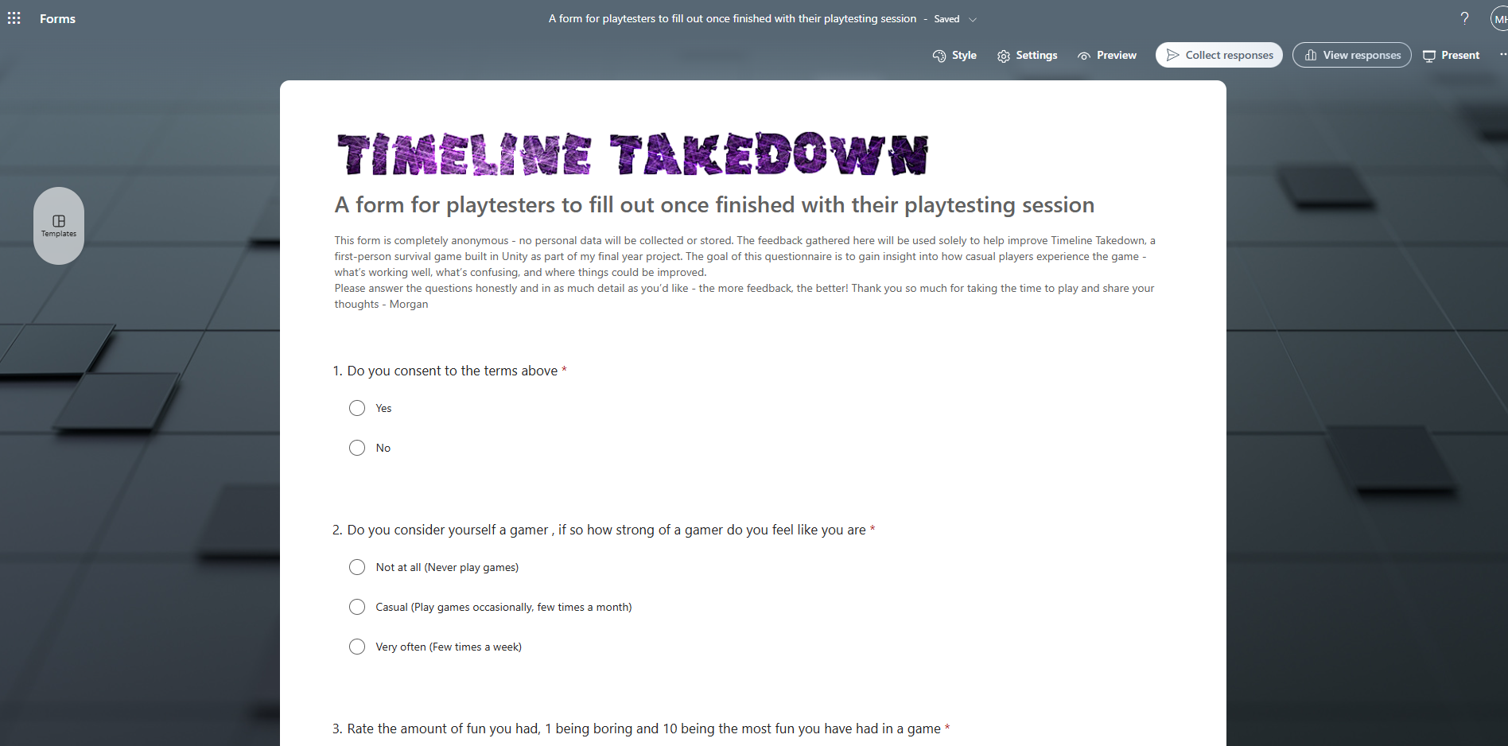

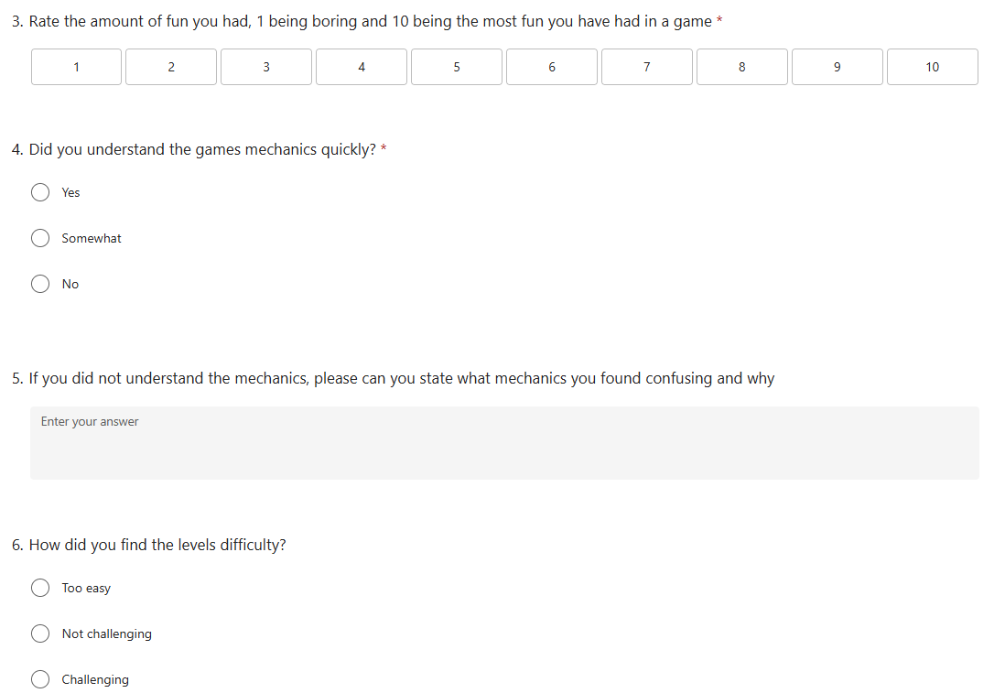

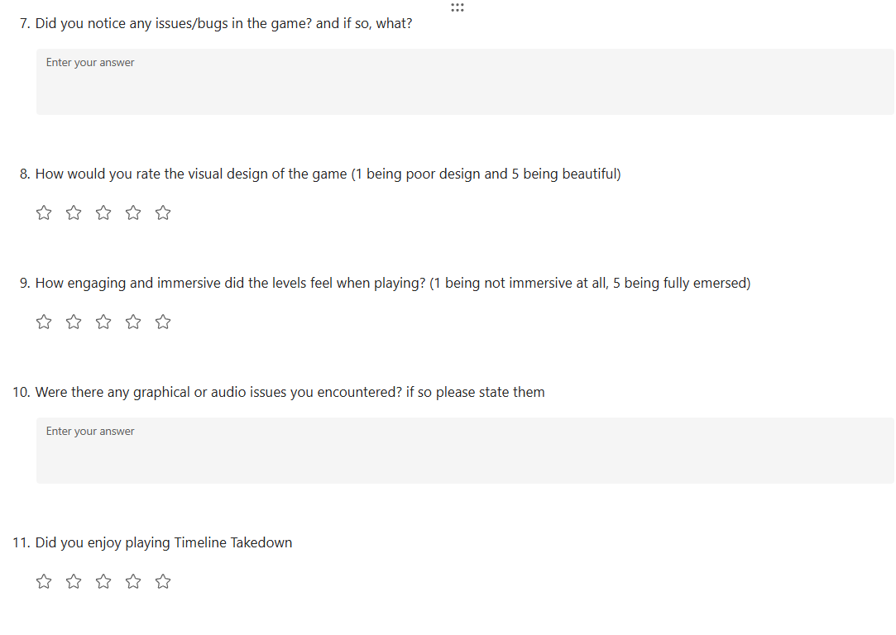

In hindsight, starting with Microsoft Forms from the beginning would have improved the quality and organisation of my user testing significantly.

## Appendix 11: Poster Creation

It was a requirement to create a poster for the module, this was beneficial as it also would serve as a piece of work to promote the game and upload to social media.

The poster went to through multiple stages of development, all files related to the poster can be found here : <https://github.com/Mdot5596/Timeline-Takedown/tree/main/Documentation/Poster>

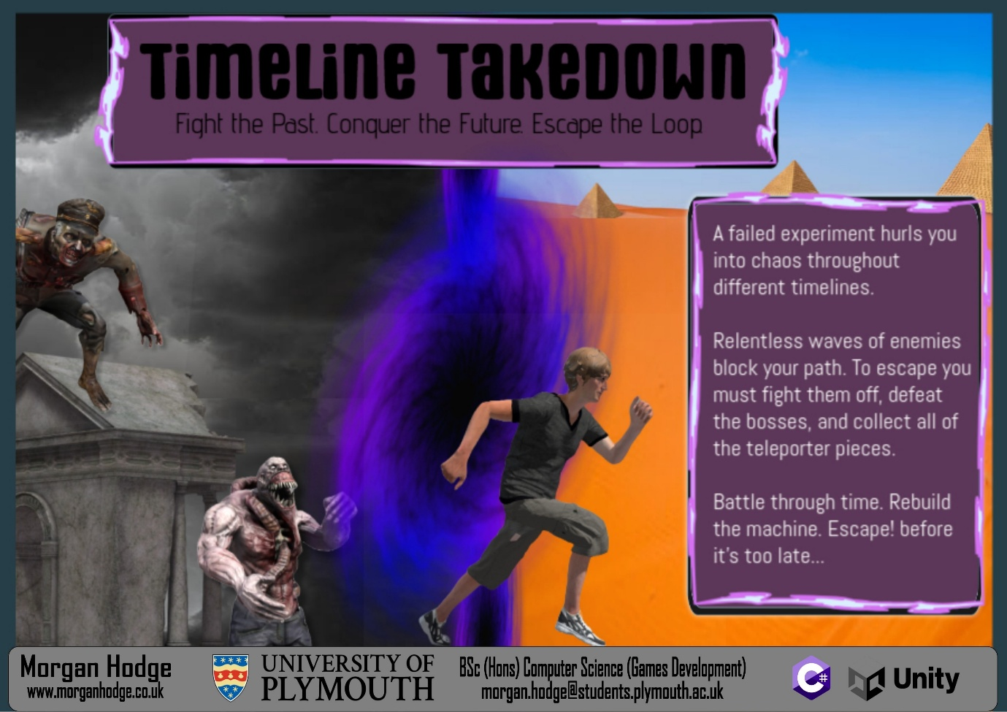

*Final Version of Poster*